Chapter 19, Solution 98

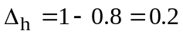

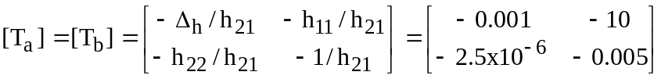

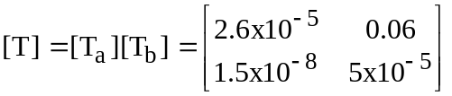

We now convert this to z-parameters

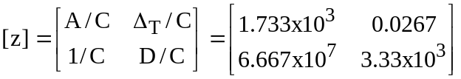

1000 I₁ z₁₁ z₂₂ I₂

+ + +
+ Z_{L}
V_{s} z₁₂ I₂ z₂₁ I₁ V_{o}
- - -
-

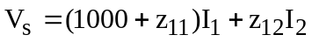 (1)

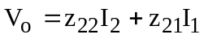 (2)

But 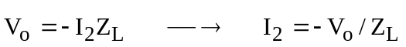 (3)

Substituting (3) into (2) gives

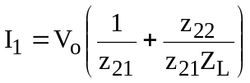 (4)

We substitute (3) and (4) into (1)

